**9 Charged for Human Trafficking in Arlington County**

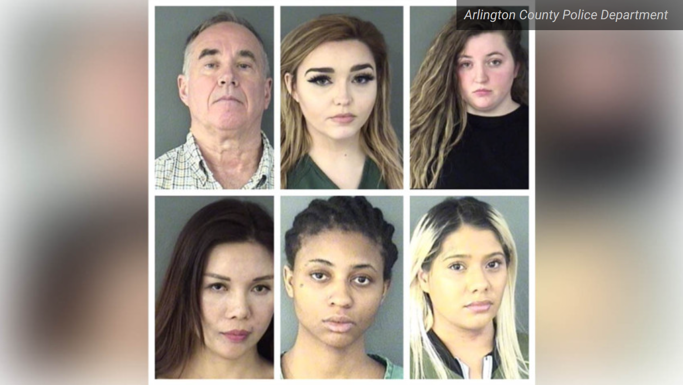

Police in Arlington County, Virginia, announced Wednesday nine arrests related to human and sex trafficking in Northern Virginia.

The two-day operation on March 21 and 22 was conducted by both the FBI Washington Field Office’s Child Exploitation and Human Trafficking Task Force and police officers from ACPD’s Criminal Investigations and Operations Sections to find victims of trafficking.

“The goals of this proactive operation...were to attempt to locate any juveniles being exploited into sex trade and help raise awareness about sex trafficking in our community,” the police department said in a news release.

Five of the people charged are from the District or Virginia, while four are from Arkansas, California, Nevada and New York

Marquilla Braxton, 21, from the District, Ashley Kibler, 22, of Washington, Virginia, Debbie Sanchez, 26, of Sacramento, California, and Wanxiu Kang, 45, of Flushing, New York, were charged with misdemeanor prostitution.

Kayle Rolle, 22, of Fayetteville, Arkansas, was charged with misdemeanor prostitution and detained on outstanding out-of-state warrants.

Faith Horton, 22, of Front Royal, Virginia, was charged with misdemeanor prostitution and felony child endangerment.

Lillian Moody, 22, also of Front Royal, was charged with misdemeanor contributing to the delinquency of a minor.

Katherine Haberman, 22, of Las Vegas, Nevada, was charged with misdemeanor prostitution and possession of marijuana.

And Gary Dulaney, 70, of Clifton, Virginia, was charged with felony use of a vehicle to promote prostitution.

Police said they identified advertisements promoting prostitution in Arlington to find the nine suspects.

Police ask anyone with information about potential trafficking in the county to call 703-558-2222 or provide anonymous tips to 866-411-8477.